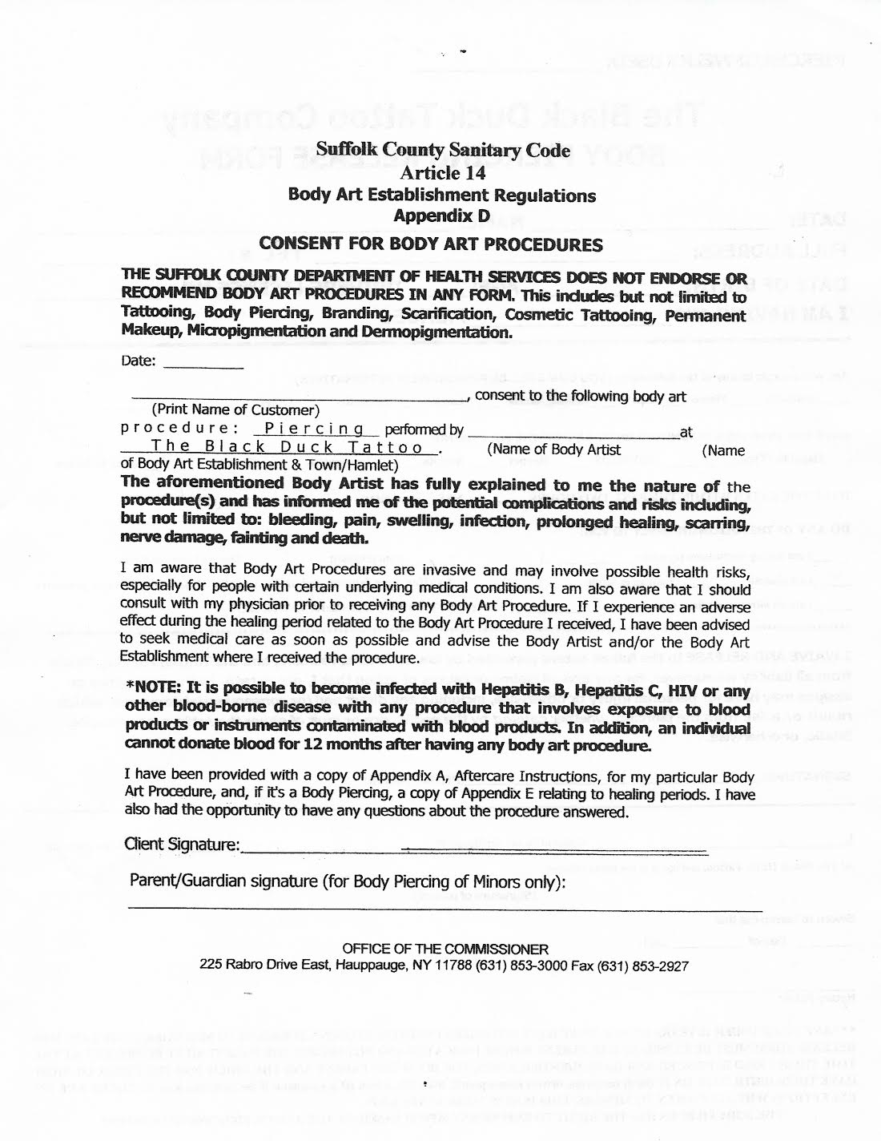
Suffolk County Sanitary Code
Article 14 Body Art Establishment Regulations
Appendix D CONSENT FOR BODY ART PROCEDURES THE SUFFOLK COUNTY DEPARTMENT OF HEALTH SERVICES DOES NOT ENDORSE OR RECOMMEND BODY ART PROCEDURES IN ANY FORM. This indudes but not limited to Tattooing, Body Piercing, Branding, Scarification, Cosmetic Tattooing, Permanent Makeup, Micropigmentation and Dermopigmentation.
Date:
-
at
, consent to the following body art (Print Name of Customer) procedure: Piercing performed by The Black Duck Tattoo
(Name of Body Artist
(Name of Body Art Establishment & Town/Hamlet) The aforementioned Body Artist has fully explained to me the nature of the procedure(s) and has informed me of the potential complications and risks including, but not limited to: bleeding, pain, swelling, infection, prolonged healing, scarring, nerve damage, fainting and death.
I am aware that Body Art Procedures are invasive and may involve possible health risks, especially for people with certain underlying medical conditions. I am also aware that I should consult with my physician prior to receiving any Body Art Procedure. If I experience an adverse effect during the healing period related to the Body Art Procedure I received, I have been advised to seek medical care as soon as possible and advise the Body Artist and/or the Body Art Establishment where I received the procedure.
*NOTE: It is possible to become infected with Hepatitis B, Hepatitis C, HIV or any other blood-borne disease with any procedure that involves exposure to blood products or instruments contaminated with blood products. In addition, an individual cannot donate blood for 12 months after having any body art procedure.
I have been provided with a copy of Appendix A, Aftercare Instructions, for my particular Body Art Procedure, and, if it's a Body Piercing, a copy of Appendix E relating to healing periods. I have also had the opportunity to have any questions about the procedure answered.
Client Signature:
Parent/Guardian signature (for Body Piercing of Minors only):
OFFICE OF THE COMMISSIONER 225 Rabro Drive East, Hauppauge, NY 11788 (631) 853-3000 Fax (631) 853-2927

