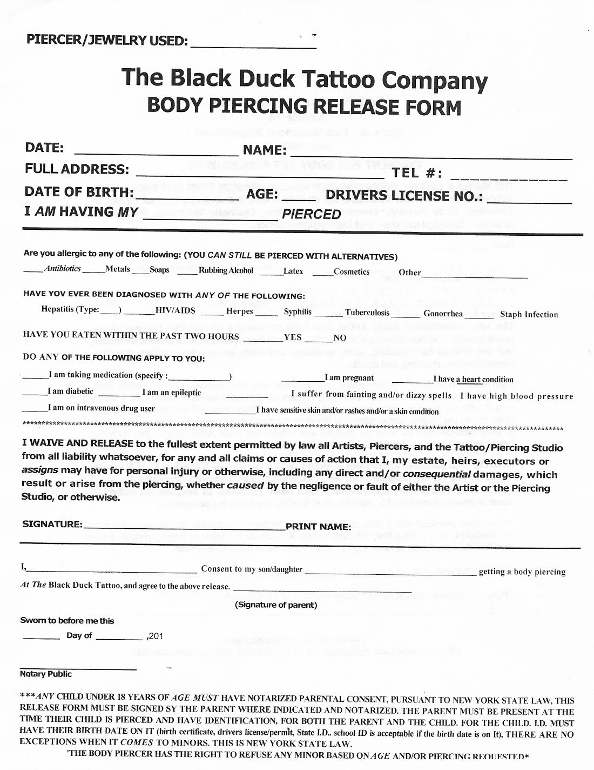
PIERCER/JEWELRY USED:
The Black Duck Tattoo Company
BODY PIERCING RELEASE FORM
DATE: FULL ADDRESS: DATE OF BIRTH: I AM HAVING MY
NAME:
TEL #: AGE: DRIVERS LICENSE NO.:
PIERCED
Are you allergic to any of the following: (YOU CAN STILL BE PIERCED WITH ALTERNATIVES) Antibiotics_ Metals___Soaps __ Rubbing Alcohol
___Cosmetics Other
HAVE YOU EVER BEEN DIAGNOSED WITH ANY OF THE FOLLOWING:
Hepatitis (Type:_ _ HIV/AIDS Herpes Syphilis
Tuberculosis
Gonorrhea
Staph Infection
HAVE YOU EATEN WITHIN THE PAST TWO HOURS_
_YES_
NO
DO ANY OF THE FOLLOWING APPLY TO YOU:
_I am taking medication (specify: I am diabetic __ I am an epileptic
I am pregnant
_I have a heart condition I suffer from fainting and/or dizzy spells I have high blood pressure I have sensitive skin and/or rashes and/or a skin condition
I am on intravenous drug user
***************
********************************************************************************************************************************
I WAIVE AND RELEASE to the fullest extent permitted by law all Artists, Piercers, and the Tattoo/Piercing Studio from all liability whatsoever, for any and all claims or causes of action that I, my estate, heirs, executors or assigns may have for personal injury or otherwise, including any direct and/or consequential damages, which result or arise from the piercing, whether caused by the negligence or fault of either the Artist or the Piercing Studio, or otherwise.
SIGNATURE:
_PRINT NAME:
getting a body piercing
Consent to my son/daughter At The Black Duck Tattoo, and agree to the above release.
(Signature of parent)
Sworn to before me this - Day of __
,201
Notary Public
***ANY CHILD UNDER 18 YEARS OF AGE MUST HAVE NOTARIZED PARENTAL CONSENT, PURSUANT TO NEW YORK STATE LAW, THIS RELEASE FORM MUST BE SIGNED SY THE PARENT WHERE INDICATED AND NOTARIZED. THE PARENT MUST BE PRESENT AT THE TIME THEIR CHILD IS PIERCED AND HAVE IDENTIFICATION, FOR BOTH THE PARENT AND THE CHILD. FOR THE CHILD. ID. MUST HAVE THEIR BIRTH DATE ON IT (birth certificate, drivers license permit. State I.D.. school ID is acceptable if the birth date is on It), THERE ARE NO EXCEPTIONS WHEN IT COMES TO MINORS. THIS IS NEW YORK STATE LAW.
"THE BODY PIERCER HAS THE RIGHT TO REFUSE ANY MINOR BASED ON AGE AND/OR PIERCING REQUESTED*

